Day 2 – Choosing your path?

It’s Day #2 and it’s time to learn about what it means to be a prime contractor.

Most consultants advocate firms getting certified and registered to become prime contractors. I don’t believe that this is the best approach for the majority of companies out there.

If you look at the KPI’s (Key Performance Indicators) of the average small business, they cannot deliver and execute on these large multi-million bundled contracts.

Unlike other industries and sectors, the government bundles seemingly unrelated contracts together for maximum effectiveness of spending dollars. Often times the scope of services is completely different from your expertise thus requiring you to go outside your field for assistance. This makes your firm vulnerable to failing to perform and danger of jeopardizing your reputation, losing money and tarnishing relationships.

In today’s lesson we will discuss the differences between being a subcontractor vs. a prime contractor.

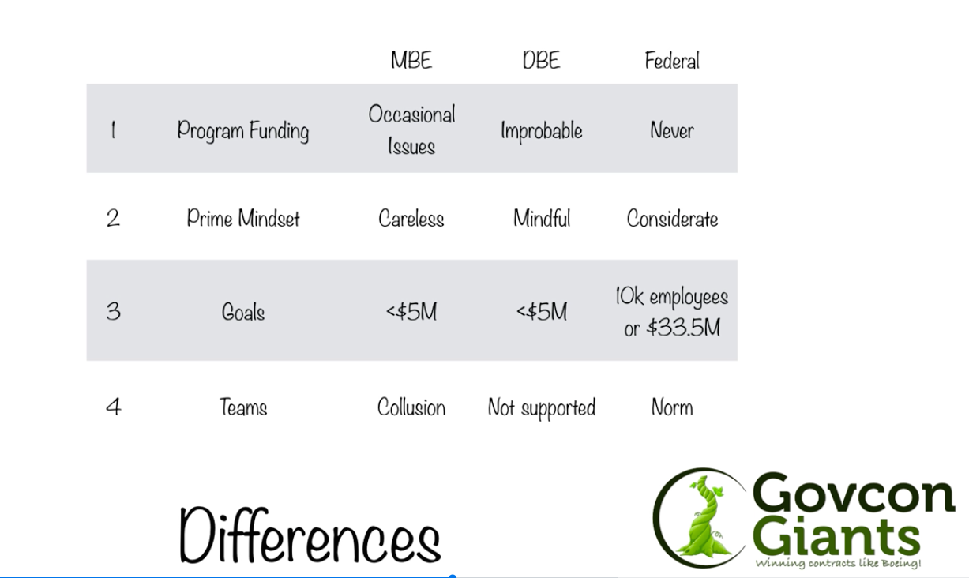

Complete Day 3 Training Now

Eric Coffie
P.S. Learn how I have closed more than $10 million in sales as a subcontractor to certified firms.

